**UML DIAGRAM FOR SHOPPING CART SYSTEM**

**Aim:**

To draw UML diagram for shopping cart system using umbrello tool.

**UML DIAGRAM**

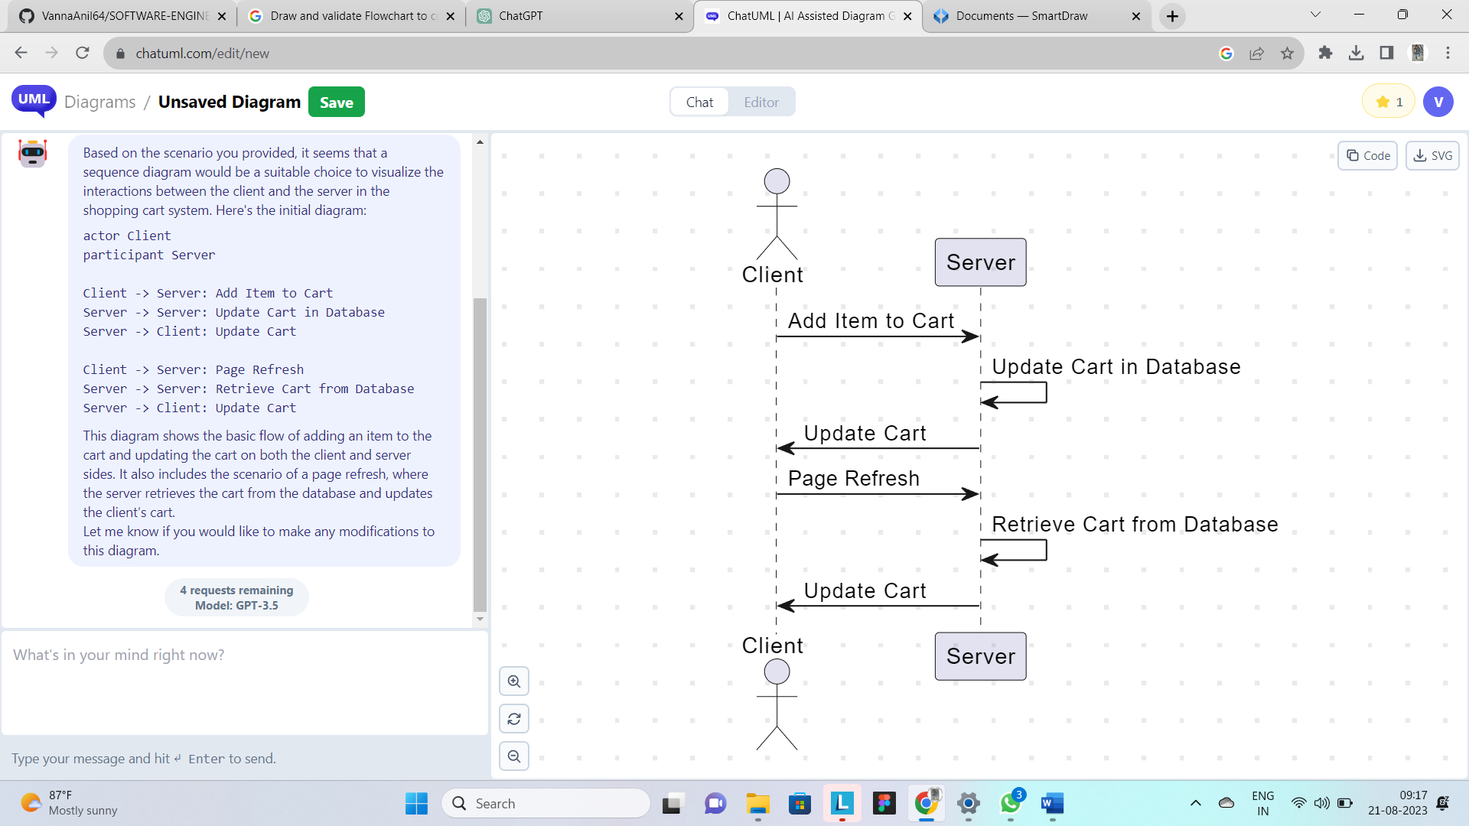

**RESULT**

Hence these diagrams for shopping cart system are drawn and verified successfully.